Test FE  
Summer 2023  
Subject: WED201c  
Duration: 120 minutes

**Objectives:**

* Create a style sheet file and link it to the html file.

**Background:**

- In this practice exam, you are given a folder “**Resource**”. You are going to use page “index.html” to finish the exam. **You don’t be change image.**

- After completing the final exam, The student will submit the Resource folder to the Server.

**Before styling index.html page**

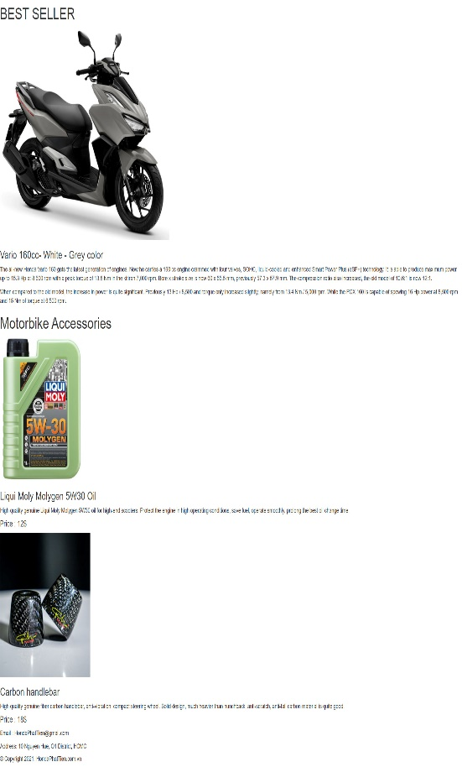

Scroll

**After styling index.html page**

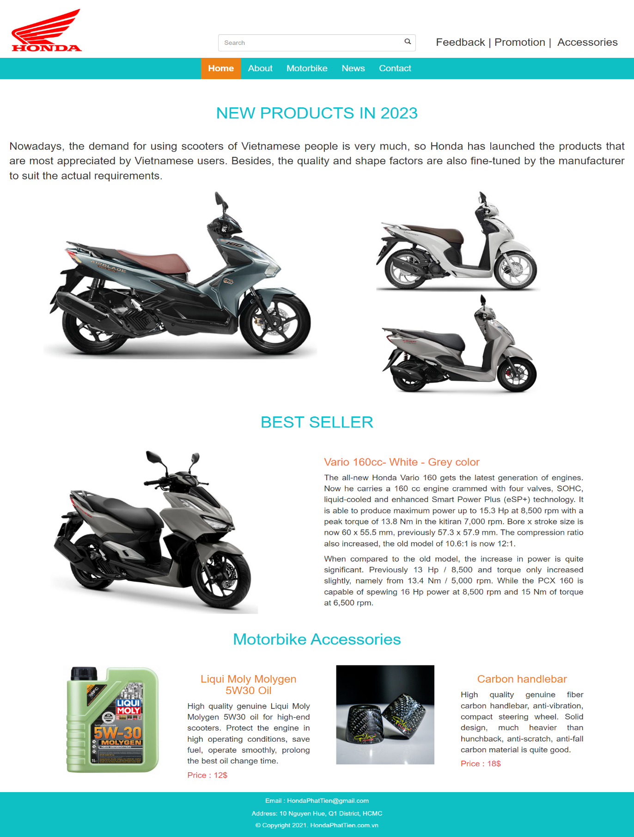

**Web Page interface on mobile devices**



Scroll

**Required:**

Create a file called styleindex.css to format the index.html page and save it to the **Resource/css folder**.

**Evaluation**

**A. HTML [0.5 points]**

* Embed the styleindex.css file in the head tag of the index.html page [0.5 points].

**B. CSS [ 9.5 points]**

* Use a 12-column grid system to format web page content [2 points].
* Use margin and padding to create the right spacing for the content [1 point].
* Use css to format the logo and search as shown above [ 1 point].
* Use css to format the content on the right of the Search [ 0.5 points].
* Use css to format the menu as shown above [ 0.5 points].
* Use css to format images and text of “NEW PRODUCTS IN 2023” content [1 point].
* Use css to format image and text of “BEST SELLER” content [1 point].
* Use css to format images and text of “Motorbike Accessories” content [1 point].
* Use color and background to format for the “footer” content [0.5 points].
* Use css to format website content on mobile devices [ 1 point].

**The End**